1. SELECT nama, harga, stok, tgl_transaksi, jumlah_beli, total_harga FROM `tb_obat` JOIN tb_transaksi ON tb_transaksi.id_obat = tb_obat.id_obat WHERE stok > 10;

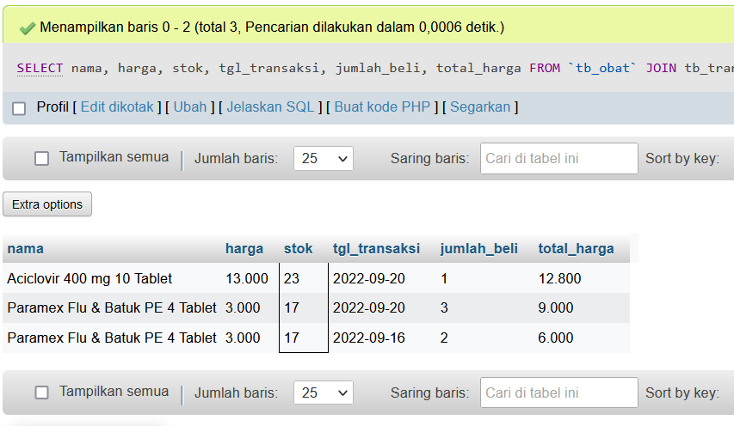

1. SELECT nama, harga, stok, tgl_transaksi, jumlah_beli, total_harga FROM `tb_obat` JOIN tb_transaksi ON tb_transaksi.id_obat = tb_obat.id_obat WHERE nama LIKE '%ml%';

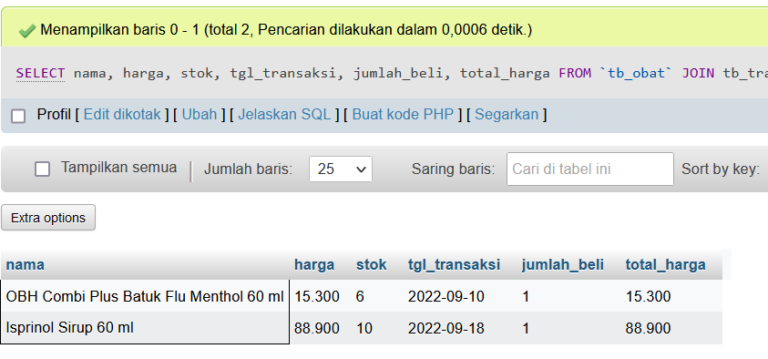

1. SELECT nama, harga, stok, tgl_transaksi, jumlah_beli, total_harga FROM `tb_obat` RIGHT JOIN tb_transaksi ON tb_transaksi.id_obat = tb_obat.id_obat WHERE harga > 5.000;

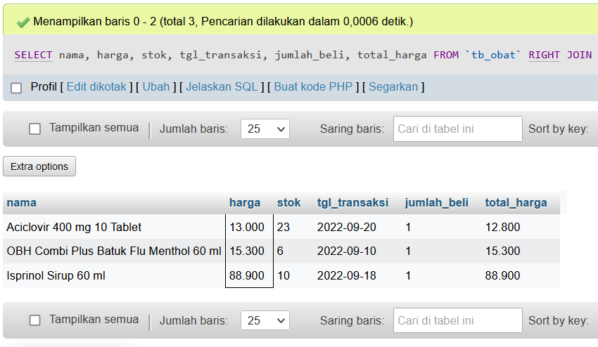

1. SELECT nama, harga, stok, tgl_transaksi, jumlah_beli, total_harga FROM `tb_obat` LEFT JOIN tb_transaksi ON tb_transaksi.id_obat = tb_obat.id_obat WHERE harga > 5.000;

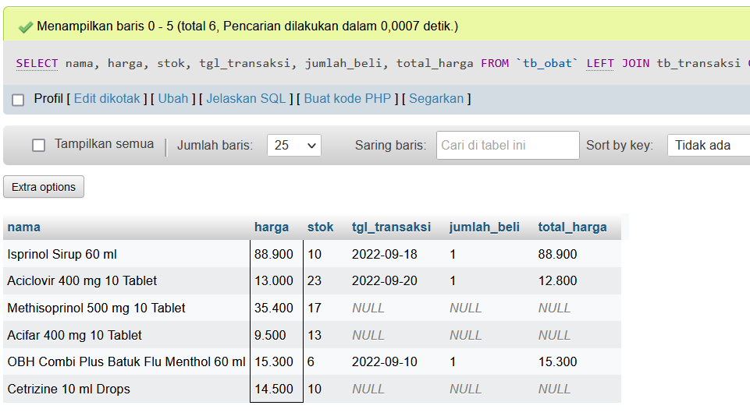

1. SELECT nama, harga, stok, tgl_transaksi, jumlah_beli, total_harga FROM `tb_obat` LEFT JOIN tb_transaksi ON tb_transaksi.id_obat = tb_obat.id_obat WHERE nama LIKE '%a%' ORDER BY nama DESC;

